Shotgun Metagenomics
Taxonomic & Functional Profiling Pipeline
Kraken2 + Bracken • MetaPhlAn • HUMAnN 3.9
Purpose: A reproducible command-line workflow for taxonomic profiling and functional/metabolic profiling of shotgun metagenomic reads. The commands below reflect the working environment and successful SRR33005305 analysis documented during this project.

1. Workflow at a glance
The analysis has two complementary taxonomic approaches and one functional layer:
- Kraken2 → broad k-mer-based taxonomic classification; Bracken → abundance re-estimation at a selected taxonomic rank.
- MetaPhlAn → marker-gene-based taxonomic profiling; the resulting profile can guide HUMAnN's functional search.
- HUMAnN → microbial gene-family and metabolic-pathway profiling.
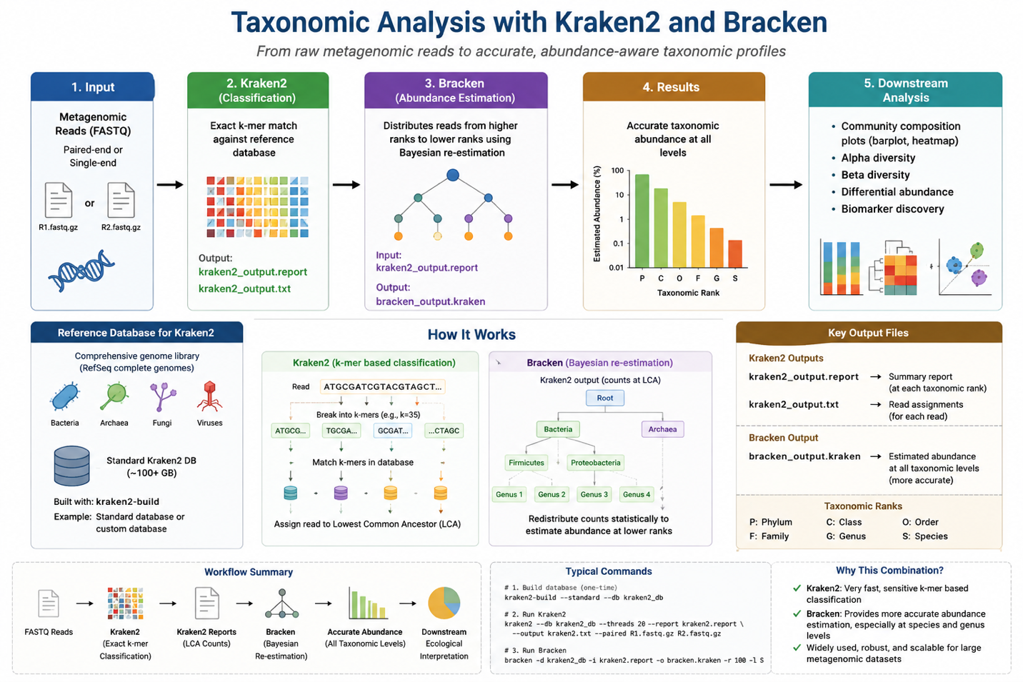
Figure 1. Kraken2–Bracken taxonomic profiling overview.
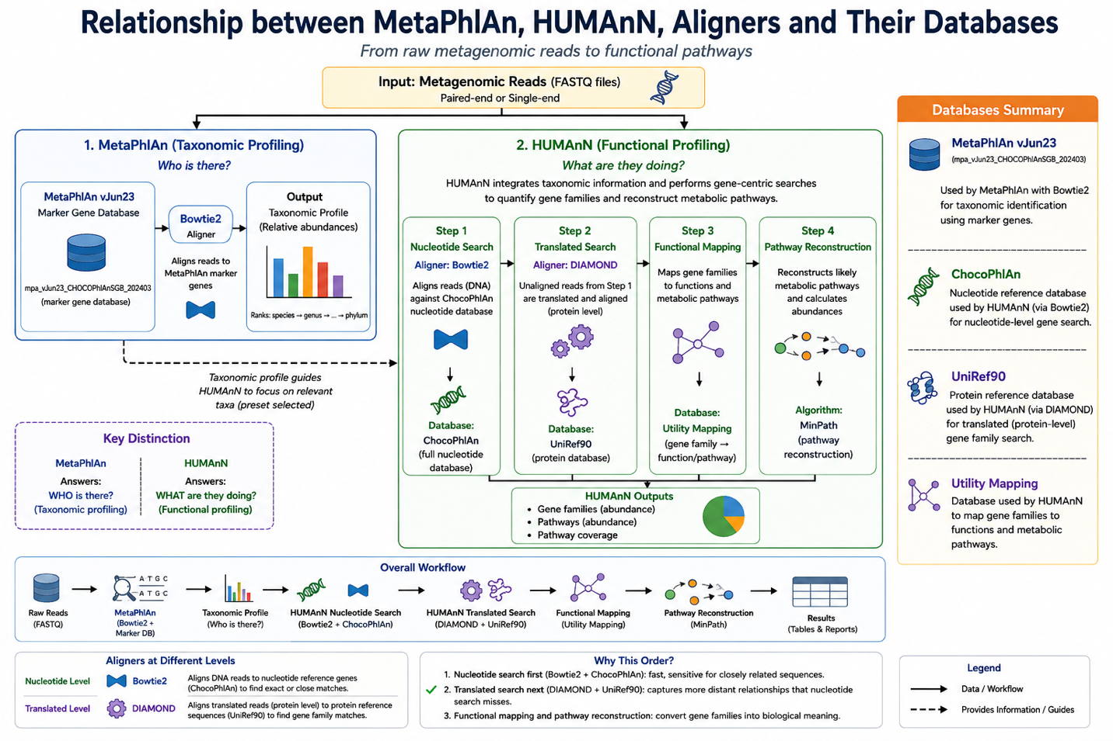
Figure 2. Relationship among MetaPhlAn, HUMAnN, aligners, and reference databases.

2. Recommended project organization
Correction from the earlier draft: Use one consistent naming scheme. The earlier document mixed 08_abundance/08_taxonomy and 09_function/09_functional, and used both human and humann. The structure below matches the commands actually used in this project.
cd ~/Metagenomics_Analysis
mkdir -p \
00_metadata \
01_raw_data \
02_fastqc_raw \
03_trimmed \
04_fastqc_trimmed \
05_multiqc \
06_host_removed \
07_taxonomy \
08_abundance \
09_functional \
10_assembly \
11_genes \
12_MAGS \
13_AMR \
14_virulence \
15_MGE \
16_R_analysis \
17_figures \
18_results \
Scripts

3. Input data and basic QC
For SRA data, download the accession, split paired reads, compress them, and verify the files. FastQC/fastp/MultiQC should be performed before taxonomy and functional profiling when raw-read QC is part of the project.
conda create -n metagenomics \
-c conda-forge -c bioconda \
sra-tools fastqc fastp multiqc seqkit pigz -y
conda activate metagenomics
prefetch SRR33005305
fasterq-dump SRR33005305 \
--split-files --threads 8 --outdir 01_raw_data
pigz -p 8 01_raw_data/*.fastq
seqkit stats 01_raw_data/*.fastq.gz
df -h
free -h
nproc
Important: Do not treat FASTQ concatenation as a replacement for paired-end handling in tools that explicitly support paired reads. Kraken2 accepts R1/R2 directly. HUMAnN 3.9 accepts one input file, so in this project the paired files were concatenated for HUMAnN; the successful run confirms that this approach worked for this dataset.

4. Taxonomic profiling with Kraken2 + Bracken

4.1 Install tools
conda create -n kraken_env \
-c conda-forge -c bioconda \
kraken2=2.1.6 bracken=3.0 -y
conda activate kraken_env
kraken2 --version
bracken --version

4.2 Kraken2 database
Database choice: Use a database appropriate for the project and record its exact build/version. Large standard databases can require substantial storage.
mkdir -p ~/Metagenomics_Analysis/databases/kraken2
kraken2-build \
--standard \
--use-ftp \
--db ~/Metagenomics_Analysis/databases/kraken2 \
--threads 20
kraken2-inspect \
--db ~/Metagenomics_Analysis/databases/kraken2 | head -30
Alternative: If a full standard database is impractical, use a documented prebuilt/minikraken-style database and verify its checksum before extraction. Record the exact archive name and date in your metadata.

4.3 Run Kraken2
mkdir -p 07_taxonomy/kraken2
kraken2 \
--db ~/Metagenomics_Analysis/databases/kraken2 \
--paired \
--gzip-compressed \
--threads 20 \
--report 07_taxonomy/kraken2/SRR33005305.kraken2.report \
--output 07_taxonomy/kraken2/SRR33005305.kraken2.out \
01_raw_data/SRR33005305_1.fastq.gz \
01_raw_data/SRR33005305_2.fastq.gz
head -30 07_taxonomy/kraken2/SRR33005305.kraken2.report
Interpretation: Kraken2 assigns reads to taxonomic nodes using exact k-mer matches in its database. The report summarizes classified reads across the taxonomic hierarchy. Kraken2 is the classifier; its database supplies the reference k-mers.

4.4 Run Bracken
Bracken re-estimates abundance from the Kraken2 classification and redistributes reads to a requested taxonomic rank. The read-length parameter (-r) must match the read length represented by the Bracken database build; do not blindly copy a value between datasets.
seqkit stats \
01_raw_data/SRR33005305_1.fastq.gz \
01_raw_data/SRR33005305_2.fastq.gz
bracken \
-d ~/Metagenomics_Analysis/databases/kraken2 \
-i 07_taxonomy/kraken2/SRR33005305.kraken2.report \
-o 07_taxonomy/kraken2/SRR33005305.bracken.species.txt \
-r 200 -l S -t 10
bracken \
-d ~/Metagenomics_Analysis/databases/kraken2 \
-i 07_taxonomy/kraken2/SRR33005305.kraken2.report \
-o 07_taxonomy/kraken2/SRR33005305.bracken.genus.txt \
-r 200 -l G -t 10
Caution: Before using -r 200 in the final workflow, verify that the Kraken2/Bracken database has been built for 200-bp reads. Your SRR33005305 reads were variable-length (~214–221 bp in the inspected records), so document the exact Bracken database/read-length configuration.

5. Taxonomic profiling with MetaPhlAn
MetaPhlAn provides a complementary, marker-gene-based taxonomic profile. It should not be treated as a duplicate of Kraken2/Bracken: the methods use different reference concepts and classification strategies.
Key distinction: Kraken2 asks which taxonomic nodes can be supported by database k-mers; MetaPhlAn uses clade-specific microbial marker information to estimate relative abundance.

5.1 Working MetaPhlAn environment
conda create -n humann39_env \
-c conda-forge -c bioconda \
python=3.11 metaphlan=4.1.1 \
bowtie2=2.5.5 diamond=2.2.5 pip -y
conda activate humann39_env
python --version
metaphlan --version
bowtie2 --version
diamond version
pip install humann==3.9
humann --version
Why this environment was needed: The first HUMAnN environment contained MetaPhlAn 4.2.5 with a newer database. HUMAnN 3.9 could not communicate cleanly with that MetaPhlAn output/interface. The working solution was to use HUMAnN 3.9 with MetaPhlAn 4.1.1 and the vJun23 MetaPhlAn database.

5.2 Install the compatible MetaPhlAn database
mkdir -p databases/metaphlan/vJun23
metaphlan \
--install \
--db_dir databases/metaphlan/vJun23 \
--index mpa_vJun23_CHOCOPhlAnSGB_202403
metaphlan --version
ls -lh databases/metaphlan/vJun23/
Important: Do not use a generic metaphlan --install in the final documented workflow if it silently selects a newer database. The explicit --db_dir and --index make the database version reproducible.

5.3 Run MetaPhlAn
mkdir -p 08_taxonomy/metaphlan
metaphlan \
01_raw_data/SRR33005305_1.fastq.gz,01_raw_data/SRR33005305_2.fastq.gz \
--input_type fastq \
--nproc 20 \
--mapout 08_taxonomy/metaphlan/SRR33005305.mapout.bz2 \
-o 08_taxonomy/metaphlan/SRR33005305_metaphlan_profile.txt
head -30 08_taxonomy/metaphlan/SRR33005305_metaphlan_profile.txt
Output: The profile reports clade names, NCBI tax IDs, relative abundance, and additional merged-species information where applicable.

6. HUMAnN functional profiling

6.1 The critical concept: aligner vs database
This distinction was clarified during the project and should be explicit in the final document:
Stage | Aligner / algorithm | Reference database | Purpose
MetaPhlAn taxonomy | Bowtie2 | MetaPhlAn marker database | Align reads to marker sequences for taxonomic profiling.
HUMAnN nucleotide search | Bowtie2 | ChocoPhlAn | Align DNA reads to reference microbial genes.
HUMAnN translated search | DIAMOND | UniRef90 | Search translated nucleotide reads against protein sequences to identify gene families.
Functional mapping | Mapping/database | Utility Mapping | Connect gene families to functional annotations and pathways.
Pathway reconstruction | MinPath | Pathway definitions | Infer likely metabolic pathways from detected functions.

6.2 HUMAnN databases
mkdir -p ~/Metagenomics_Analysis/databases/humann/chocophlan
humann_databases \
--download chocophlan full \
~/Metagenomics_Analysis/databases/humann/chocophlan
mkdir -p ~/Metagenomics_Analysis/databases/humann/uniref90
humann_databases \
--download uniref uniref90_diamond \
~/Metagenomics_Analysis/databases/humann/uniref90
mkdir -p ~/Metagenomics_Analysis/databases/humann/utility_mapping
humann_databases \
--download utility_mapping full \
~/Metagenomics_Analysis/databases/humann/utility_mapping
Important: These three HUMAnN databases have different jobs. ChocoPhlAn is the nucleotide reference used by the Bowtie2 search; UniRef90 is the protein reference used by DIAMOND; Utility Mapping connects gene-family identifiers to functional/pathway information.

6.3 Configure HUMAnN
humann_config --update database_folders nucleotide \
/home/turtle/Metagenomics_Analysis/databases/humann/chocophlan/chocophlan
humann_config --update database_folders protein \
/home/turtle/Metagenomics_Analysis/databases/humann/uniref90/uniref
humann_config --update database_folders utility_mapping \
/home/turtle/Metagenomics_Analysis/databases/humann/utility_mapping/utility_mapping
humann_config --print
Why humann_config --print? It is a verification step. It confirms that HUMAnN is pointing to the intended full databases rather than the small DEMO databases bundled with the package.

6.4 Prepare HUMAnN input
mkdir -p 01_raw_data/humann_input
cat \
01_raw_data/SRR33005305_1.fastq.gz \
01_raw_data/SRR33005305_2.fastq.gz \
> 01_raw_data/humann_input/SRR33005305_combined.fastq.gz
zcat 01_raw_data/humann_input/SRR33005305_combined.fastq.gz | head -8
zcat 01_raw_data/humann_input/SRR33005305_combined.fastq.gz | wc -l
Why concatenate? HUMAnN 3.9 uses a single input stream in this workflow. The paired files were concatenated so HUMAnN could process the complete read set. Kraken2 and MetaPhlAn were run directly with the paired reads.

6.5 Successful HUMAnN command
mkdir -p 09_functional/humann
humann \
-i 01_raw_data/humann_input/SRR33005305_combined.fastq.gz \
-o 09_functional/humann \
--threads 20 \
--search-mode uniref90 \
--output-basename SRR33005305 \
--metaphlan-options "--bowtie2db /home/turtle/Metagenomics_Analysis/databases/metaphlan/vJun23 --index mpa_vJun23_CHOCOPhlAnSGB_202403" \
-v
Why this version of the command? The explicit --metaphlan-options forces HUMAnN to use the compatible vJun23 MetaPhlAn database. This avoided the earlier database-version mismatch and produced the successful SRR33005305 functional profile.

7. HUMAnN outputs and interpretation
Output file | Main information | Typical use
genefamilies.tsv | Gene-family abundance; includes unstratified and organism-stratified entries. | Functional feature matrix; downstream functional comparison.
pathabundance.tsv | Estimated abundance of reconstructed pathways. | Compare metabolic pathway abundance among samples.
pathcoverage.tsv | Fraction/completeness of pathway components detected. | Assess whether a pathway is sufficiently represented.

7.1 SRR33005305: observed output
Gene families: 108,186 rows were present in the raw HUMAnN gene-family table. The table contains both overall UniRef90 entries and stratified entries such as gene-family|g__Bacteroides.s__Bacteroides_thetaiotaomicron.
Pathways: 783 rows were present in both pathway-abundance and pathway-coverage tables. These rows include actual pathways plus special categories such as UNMAPPED and UNINTEGRATED and organism-stratified pathway entries.
UNMAPPED: Reads/functions that HUMAnN could not assign at the relevant stage. It is not a biological pathway.
UNINTEGRATED: Gene-family abundance that could not be integrated into a complete known pathway. It is a HUMAnN category, not itself a metabolic pathway.
RPKs: The gene-family abundance column in this run is reported as RPKs. It should not be interpreted directly as relative abundance without appropriate downstream normalization/processing.

8. Recommended multi-sample workflow
Once every sample has been processed, do not immediately compare raw TSV rows. First build consistent sample-by-feature matrices.
- Run Kraken2 and Bracken for every sample using the same database and documented Bracken settings.
- Run MetaPhlAn for every sample using the same MetaPhlAn database/index.
- Run HUMAnN for every sample using the same HUMAnN database versions and configuration.
- Join/merge HUMAnN gene-family tables across samples.
- Join/merge HUMAnN pathway-abundance tables across samples.
- Keep pathway coverage as a separate matrix.
- Remove or separately report UNMAPPED, UNINTEGRATED, and stratified rows as appropriate for the analysis.
- Normalize/transform the appropriate feature matrix before statistical comparison.
- Perform community composition, differential abundance, pathway analysis, and visualization in R/Python.

9. What should NOT be done
- Do not mix MetaPhlAn database versions between samples.
- Do not compare HUMAnN outputs generated with different reference database versions without documenting the difference.
- Do not count stratified and unstratified HUMAnN rows as independent pathways.
- Do not interpret UNMAPPED or UNINTEGRATED as biological pathways.
- Do not assume Bracken -r 200 is correct unless the Bracken database was built for that read length.
- Do not normalize a single sample and then call it a multi-sample abundance analysis; normalization/comparison is most useful after the sample matrix has been constructed.

10. Reproducibility checklist
☐ Record sample/accession IDs and metadata.
☐ Record tool versions: Kraken2, Bracken, MetaPhlAn, HUMAnN, Bowtie2, DIAMOND.
☐ Record database names/builds and download dates.
☐ Keep the exact commands used for each sample.
☐ Record CPU threads and major parameters.
☐ Keep raw reports and final TSV outputs unchanged.
☐ Use consistent output directory names.
☐ Record any deviations or troubleshooting steps.

11. Quick conceptual summary
The easiest way to remember the workflow is:
Kraken2/Bracken = broad taxonomy | MetaPhlAn = marker-based taxonomy | HUMAnN = function
Bowtie2 = nucleotide aligner | ChocoPhlAn = nucleotide reference | DIAMOND = translated/protein aligner | UniRef90 = protein reference
Utility Mapping + MinPath → functional annotations and metabolic pathways

